LECTURE 6
DIGITAL SIGNATURES

1. Digital Signatures
A digital signature is a cryptographic technique used to verify the identity of a sender and ensure that a message or transaction has not been changed. It works using public key cryptography, where each user has a private key and a public key.
In blockchain systems, digital signatures are very important because they help prove that a transaction was really created by the owner of the funds. They also protect the system from fraud and unauthorized actions.
Digital signatures provide security, trust, and verification in digital communication.
1.1 What is a Digital Signature?
Definition
A digital signature is a mathematical method used to verify that a digital message or transaction was created by the correct person and has not been altered.
It is created using the sender's private key and can be verified by others using the sender's public key.
This process ensures that the message is authentic and trustworthy.
Use in Blockchain Transactions
In blockchain, digital signatures are used to authorize transactions.
When a user wants to send cryptocurrency, they sign the transaction using their private key. This signature proves that the transaction was created by the real owner of the funds.
Network nodes then use the public key to verify the signature before accepting the transaction. If the signature is valid, the transaction is added to the blockchain.
1.2 Purpose of Digital Signatures
Digital signatures provide three main security properties: authentication, integrity, and non-repudiation.
Authentication
Authentication means confirming the identity of the sender.
A digital signature proves that the message or transaction was created by the person who owns the private key. This helps ensure that the sender is genuine and not an attacker.
Integrity
Integrity means ensuring that the data has not been changed.
When a message is digitally signed, any change in the message will cause the signature verification to fail. This allows the receiver to detect if someone tried to modify the data.
Non-Repudiation
Non-repudiation means that the sender cannot deny sending the message or transaction.
Since only the owner of the private key can create the digital signature, the sender cannot later claim that they did not perform the action.
1.3 Digital Signature vs Electronic Signature
A digital signature and an electronic signature are both used to sign documents electronically, but they are not the same.
An electronic signature is a simple digital form of a handwritten signature. It can be a typed name, scanned signature, or a drawn signature on a screen. It mainly shows that a person agrees with the content of a document.
A digital signature, on the other hand, uses cryptography to provide stronger security. It uses mathematical algorithms and a pair of keys (private key and public key) to verify the identity of the sender and protect the data.
Because of this, digital signatures are more secure and harder to forge than electronic signatures.
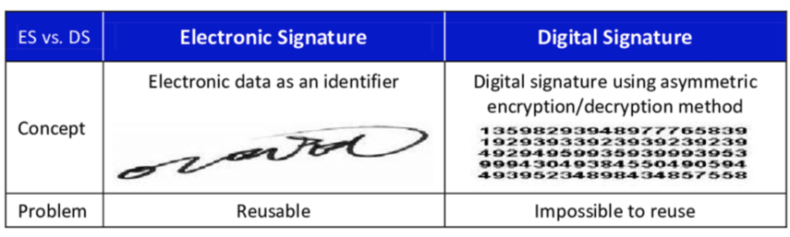
Key Differences
Electronic Signature
- Simple electronic form of a signature
- Can be a scanned or typed signature
- Mainly used for agreement or approval
- Can sometimes be copied or reused
Digital Signature
- Uses cryptographic algorithms
- Created using private and public keys
- Provides authentication, integrity, and non-repudiation
- Very secure and difficult to forge or reuse
1.4 Basic Concept of Digital Signature
A digital signature works using public key cryptography, which uses two different but related keys. These keys help create and verify the signature.
The two main components are private key and public key.
Private Key
A private key is a secret key that is kept only by the owner. It is used to create the digital signature.
When a person wants to sign a message or transaction, they use their private key to generate the signature. Because the private key is secret, only the owner can create that signature.
If someone else gets access to the private key, they could create fake signatures, so it must always be kept secure.
Public Key
A public key is a key that is shared with others. It is mathematically related to the private key.
The public key is used by other people or network nodes to verify the digital signature. It helps confirm that the signature was created by the correct private key.
In blockchain systems, the public key is often used to generate a user's address.
Signing and Verification Process
The digital signature process usually involves two main steps: signing and verification.
1. Signing
- The sender creates a message or transaction.
- The sender uses their private key to generate a digital signature.
- The message and the signature are then sent to the receiver or network.
2. Verification
- The receiver uses the sender's public key to check the signature.
- If the signature is valid, it proves that the message came from the correct sender and was not changed.
- If the signature is invalid, the message is rejected.
This process ensures security, authenticity, and trust in digital communication and blockchain transactions.

2. Importance of Digital Signatures
Digital signatures are very important in modern digital systems, especially in blockchain, online banking, and secure communication. They help ensure that transactions and messages are secure and trustworthy.
They provide three major benefits: authentication, data integrity, and non-repudiation.
Authentication of Transactions
Digital signatures verify the identity of the sender.
In blockchain, when a user sends a transaction, they sign it using their private key. This proves that the transaction was created by the real owner of the funds. Network nodes verify this using the public key before accepting the transaction.
Data Integrity Protection
Digital signatures ensure that the data has not been modified.
If someone tries to change the transaction or message after it has been signed, the signature will no longer match. The system will immediately detect the change and reject the transaction.
Non-Repudiation
Digital signatures prevent the sender from denying that they performed the action.
Since only the owner of the private key can create the signature, they cannot later claim that they did not send the transaction or sign the document.
3. How Digital Signatures Work
Digital signatures work through a series of steps that allow a receiver to verify the authenticity and integrity of a message. The process involves two parties: the sender and the receiver. It also uses a pair of cryptographic keys (private key and public key).
The process can be explained in four main steps.
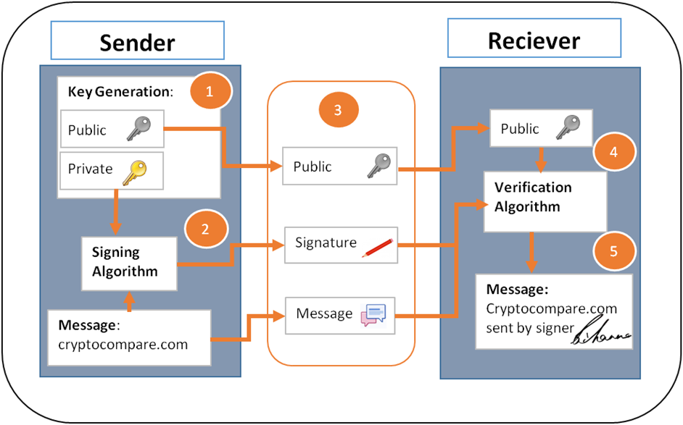
1. Sender Generates Key Pair
First, the sender generates a key pair, which includes:
- Private Key – kept secret by the sender
- Public Key – shared with others
These keys are mathematically related. The private key is used to create the digital signature, while the public key is used by others to verify it.
In blockchain systems, the private key proves ownership, while the public key helps others verify transactions.
2. Signing the Message
When the sender wants to send a message or transaction:
- The sender writes the message.
- A signing algorithm uses the sender’s private key to create a digital signature for that message.
The signature is a unique mathematical value that depends on both the message and the private key.
If the message changes, the signature will also change.
3. Sending the Message
After signing the message, the sender sends three things to the receiver or the network:
- The original message
- The digital signature
- The public key
These are transmitted together so that the receiver can verify the authenticity of the message.
4. Verification by Receiver / Network Nodes
When the receiver gets the message, they use a verification algorithm and the sender’s public key to check the signature.
The system verifies that:
- The signature was created using the correct private key
- The message has not been modified
If the verification is successful, the receiver knows that:
- The message is authentic
- The message is unchanged
- The sender is the true owner of the private key
If verification fails, the message is rejected.

4. Digital Signature Algorithms
Digital signatures are created using special cryptographic algorithms. These algorithms define how the signature is generated and how it is verified.
Different systems use different algorithms depending on their security requirements and efficiency.
Some commonly used digital signature algorithms are ECDSA, EdDSA, and elliptic curve cryptography used in blockchain systems like Ethereum.
ECDSA (Elliptic Curve Digital Signature Algorithm)
ECDSA is one of the most widely used digital signature algorithms. It is based on Elliptic Curve Cryptography (ECC).
This algorithm provides strong security while using smaller key sizes, which makes it faster and more efficient compared to some older algorithms.
ECDSA is widely used in blockchain technologies such as Bitcoin to sign and verify transactions.
Key features of ECDSA:
- Uses elliptic curve mathematics
- Provides high security
- Requires smaller keys, making it efficient
- Commonly used in cryptocurrencies
EdDSA
EdDSA (Edwards-curve Digital Signature Algorithm) is a newer and more modern digital signature algorithm.
It is designed to be faster, more secure, and easier to implement compared to older algorithms.
EdDSA uses Edwards curves, which are a special type of elliptic curve that improves performance and reduces security risks caused by incorrect implementations.
Key advantages:
- Faster signature generation
- Strong security
- Less chance of implementation errors
Elliptic Curve Cryptography Used in Ethereum (secp256k1)
Ethereum and Bitcoin use a specific elliptic curve called secp256k1.
This curve is part of Elliptic Curve Cryptography (ECC) and is used to generate public and private keys and create digital signatures.
The main benefits of secp256k1 are:
- High security with 256-bit keys
- Efficient computations
- Suitable for blockchain systems
In blockchain networks, this curve helps create wallet addresses and secure transactions.

5. Example of Digital Signature
To better understand digital signatures, we can look at a simplified mathematical example.
This example is only for understanding the concept. In real systems like blockchain, the calculations are much more complex.
Signature Generation
Assume the following values:
- Private Key = 12345
- Public Key = 67890
- Transaction Hash = 555
Ali wants to sign a transaction.
Using his private key, he generates a digital signature.
Example calculation:
Signature = Transaction Hash × Private Key
Signature = 555 × 12345 = 6,850,475
This signature is attached to the transaction.
Ali then sends the following to the network:
- Message / Transaction
- Digital Signature (6,850,475)
- Public Key (67890)
Signature Verification
When the network receives the transaction, nodes verify it using Ali’s public key.
They check whether the signature corresponds to the original transaction hash.
Example idea:
Signature ÷ Public Key → Should match the hash value.
If the result matches the expected value, the signature is valid.
This confirms that:
- The transaction was signed by the correct private key owner
- The transaction has not been modified
If the values do not match, the transaction is rejected.

6. Digital Signature vs Encryption
Digital signatures and encryption are both cryptographic techniques, but they serve different purposes.
Encryption
Encryption is used to protect the confidentiality of data.
It converts readable information into an unreadable format so that only authorized users can access it.
Example: Protecting sensitive data during transmission.
Digital Signature
A digital signature is used to verify the identity of the sender and ensure the integrity of the data.
It does not hide the message but proves that the message is authentic and unchanged.
Key Difference
Encryption | Digital Signature
Hides the data | Verifies the sender
Protects confidentiality | Ensures authenticity
Prevents unauthorized reading | Prevents forgery

7. Role of Digital Signatures in Security
Digital signatures play a very important role in maintaining security in digital systems and blockchain networks.
They help ensure that transactions and communications are safe, trustworthy, and tamper-proof.
Prevents Fraud Transactions
Digital signatures help prevent fraud by ensuring that only the real owner of the private key can create a transaction.
If someone tries to create a fake transaction without the correct private key, the system will reject it.
Prevents Unauthorized Spending
In cryptocurrency systems, users must sign transactions with their private key.
This prevents attackers from spending someone else's funds because they do not have access to the private key.
Builds Trust in Decentralized Systems
Blockchain networks operate without a central authority. Because of this, trust must be created through cryptography.
Digital signatures provide that trust by ensuring that:
- Transactions are authentic
- Data is secure
- Participants cannot cheat the system
This makes digital signatures a fundamental component of blockchain security.

8. Public and Private Key Generation
In blockchain systems such as Bitcoin and Ethereum, public and private keys are generated using Elliptic Curve Cryptography (ECC).
The specific curve used is secp256k1.
This process is:
- Mathematical
- Secure
- One-way (easy to compute forward, extremely hard to reverse)
Each blockchain user has two keys:
- Private Key → kept secret, used to sign transactions
- Public Key → shared with others, used to verify signatures
8.1 Elliptic Curve Cryptography (ECC)
Elliptic Curve Cryptography is a cryptographic technique used to generate secure keys.
Blockchain systems use the secp256k1 elliptic curve to create public and private keys.
This method provides:
- Very strong security
- Smaller key sizes
- Efficient computation
The keys are generated through mathematical operations on the elliptic curve.
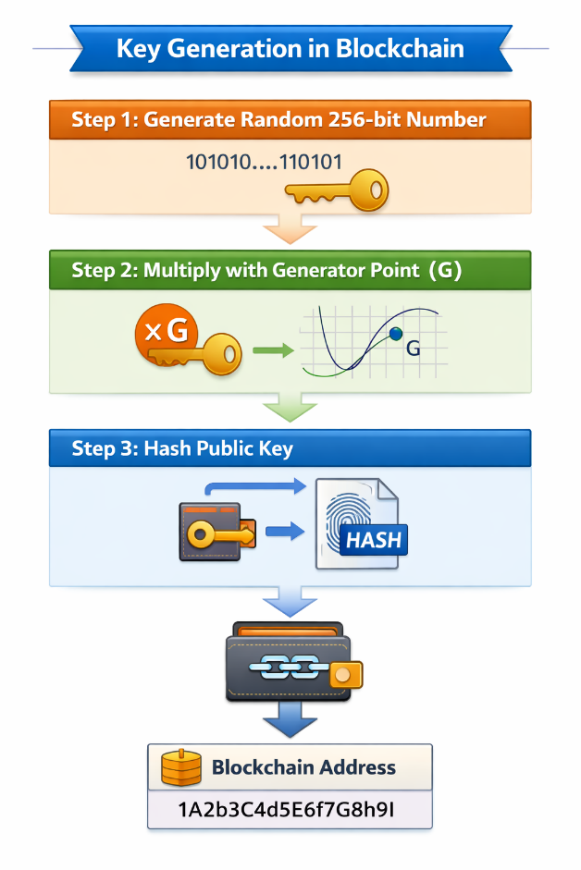
8.2 Private Key Generation
The first step is generating a private key.
Step 1: Generate a Random 256-bit Number
The private key is simply a random 256-bit number generated using a cryptographically secure random number generator (RNG).
Example (simplified):
Private Key = 101010...110101
Because it is a 256-bit number, the total number of possible private keys is extremely large:
2^256 possibilities
This huge number makes it almost impossible for attackers to guess a private key.
Important points:
- The private key must always remain secret
- It is used to sign blockchain transactions
- Whoever owns the private key controls the wallet funds
8.3 Public Key Generation
Step 2: Multiply with Generator Point (G)
The public key is generated from the private key using elliptic curve multiplication.
Formula:
Public Key = Private Key × G
Where:
- G = Generator point on the elliptic curve (secp256k1)
This multiplication is not normal multiplication. It is a special mathematical operation performed on the elliptic curve.
The result of this operation produces the public key.
Step 3: Hash the Public Key
After generating the public key, blockchain systems hash the public key to create a wallet address.
Process:
Public Key → Hash Function → Blockchain Address
Example of a blockchain address:
1A2b3C4d5E6f7G8h9I
This address is what users share with others to receive cryptocurrency.
Simple Mathematical Example (from PPT)
To understand the concept, the slide provides a very simple example.
Assume:
Private Key = 5
Generator Point G = 2
Public Key:
Public Key = 5 × 2 = 10
In real blockchain systems:
- Numbers are 256-bit
- The math uses elliptic curve operations
- The curve used is secp256k1
So the real calculations are much more complex.
Why This System Is Secure
If the formula is:
Public Key = k × G
It is easy to calculate the public key from the private key.
But it is computationally infeasible to find the private key from the public key.
This one-way mathematical property is the core security of blockchain cryptography.

9. Security of Public–Private Key System
The security of blockchain cryptography depends on the public–private key system. This system uses mathematical functions that are easy to perform in one direction but extremely difficult to reverse.
This property makes blockchain transactions secure and prevents attackers from accessing private keys.
One-Way Mathematical Function
In the public–private key system, a one-way mathematical function is used.
This means:
- It is easy to calculate the public key from the private key.
- However, it is extremely difficult to calculate the private key from the public key.
Example idea:
Public Key = Private Key × G
Where G is the generator point on the elliptic curve.
The system can easily compute the public key from the private key, but reversing the process to find the private key is computationally infeasible.
Impossible to Derive Private Key from Public Key
Even though the public key is visible to everyone, it is practically impossible to find the private key from it.
This is because:
- The key size is 256 bits
- The number of possible keys is extremely large (about 2²⁵⁶ possibilities)
Because of this huge number of possibilities, attackers cannot realistically guess the correct private key.
This property ensures that blockchain users can share their public key safely without risking their private key.

10. Key Management Clarifications
In blockchain systems, it is important to understand how keys are created, stored, and used.
Public Key Derived from Private Key
The public key is mathematically generated from the private key using elliptic curve multiplication.
Formula:
Public Key = Private Key × G
Because of this relationship, every private key has exactly one corresponding public key.
Private Key Not Stored on Blockchain
The private key is never stored on the blockchain.
The blockchain only stores:
- Transaction data
- Public key or its hash
- Digital signatures
The private key always stays with the user. If private keys were stored on the blockchain, anyone could access them and steal funds.
Wallet Software Manages Keys
Blockchain users normally do not manage keys manually. Instead, they use wallet software.
Wallet software is responsible for:
- Generating private keys
- Storing private keys securely
- Generating public keys
- Creating and signing transactions
Examples of wallets include mobile wallets, desktop wallets, and hardware wallets.

11. Importance of Randomness
Randomness is very important when generating private keys in blockchain systems.
If private keys are not generated randomly, attackers may be able to predict them and steal funds.
Secure Random Number Generation
Private keys must be generated using a cryptographically secure random number generator (RNG).
This ensures that:
- Every private key is unique
- Keys cannot be predicted
- The system remains secure
A good random number generator creates keys that are unpredictable and evenly distributed across the possible key space.
Weak Randomness Can Expose Private Keys
If the random number generator is weak or predictable, attackers may be able to guess private keys.
This can lead to serious security problems such as:
- Theft of cryptocurrency
- Unauthorized transactions
- Loss of funds
Because of this risk, blockchain systems use strong cryptographic randomness when generating private keys.

12. Transaction Verification by Nodes
In blockchain systems such as Bitcoin and Ethereum, every transaction must be verified by network nodes before it is accepted into the blockchain. Nodes are computers in the blockchain network that maintain a copy of the ledger and ensure that all transactions follow the system’s rules.
Transaction verification ensures that:
- The sender is the real owner of the funds
- The transaction has not been altered
- The sender has authorized the transaction using their private key
This verification process uses public key cryptography, digital signatures, and hashing.
12.1 What is Stored on the Blockchain
Contrary to what many people think, the blockchain does not store private keys. Instead, it stores information required to verify transactions.
Typically, the blockchain stores:
- Transaction data (amount, sender, receiver)
- Digital signature
- Public key or its hash
In many blockchain systems, the public key is not stored directly. Instead, a hash of the public key is stored. This method is called:
P2PKH (Pay to Public Key Hash)
P2PKH is a common transaction type used in Bitcoin.
In this system:
- The user’s public key is hashed.
- The resulting hash becomes the blockchain address.
- Funds are sent to this address (public key hash).
Example flow:
Public Key → Hash Function → Public Key Hash → Blockchain Address
When someone sends cryptocurrency, they send it to this address, not directly to the public key.
12.2 Spending Coins
When a user wants to spend cryptocurrency, they must prove that they own the address that received the funds.
To do this, the transaction must include three important things:
1. Public Key
The sender reveals the public key that corresponds to the address where the funds were stored.
2. Digital Signature
The sender signs the transaction using their private key.
This signature proves that the sender has the authority to spend the funds.
3. Transaction Data
This includes:
- Sender address
- Receiver address
- Amount of cryptocurrency
- Other transaction details
So a spending transaction typically contains:
Transaction Data + Public Key + Digital Signature
12.3 Verification Process
When a node in the blockchain network receives a transaction, it must verify that the transaction is valid, authorized, and unchanged. This ensures that only the owner of the private key can spend the funds and that the transaction has not been altered.
The verification process happens in three main steps.
Step 1: Verify the Public Key Hash
When funds are sent to a user, they are sent to a blockchain address, which is actually a hash of the user’s public key.
When the user wants to spend those funds, the transaction includes the public key. The node must check that this public key really belongs to the address where the funds were stored.
The node performs the following process:
- The node takes the public key provided in the transaction.
- It applies the same hash function used when the address was created.
- The generated hash is compared with the public key hash stored in the blockchain address.
Process:
Public Key
↓
Hash Function
↓
Public Key Hash
↓
Compare with Address Stored in Blockchain
If the hashes match, it confirms that the public key corresponds to the address that owns the funds.
If they do not match, the transaction is rejected.
Step 2: Verify the Digital Signature
Next, the node verifies the digital signature included in the transaction.
The digital signature was created when the sender signed the transaction using their private key.
The node uses the public key to run the signature verification algorithm.
If the signature is valid, it proves that:
- The sender owns the private key
- The transaction was authorized by the owner
If the signature is invalid, the transaction is rejected.
Step 3: Verify the Transaction Hash
The final step ensures that the transaction data has not been modified after it was signed.
When the sender creates the transaction:
- The transaction data is hashed.
- The sender signs this hash using their private key to produce the digital signature.
During verification, the node performs these actions:
- The node recalculates the hash of the transaction data.
- It uses the public key and the digital signature to obtain the original hash that was signed.
- The node compares both hashes.
Process idea:
Transaction Data
↓
Hash Function
↓
New Transaction Hash
Signature + Public Key
↓
Verification Algorithm
↓
Recovered Signed Hash
Compare both hashes.
If the hashes match:
✔ The transaction data has not been altered
✔ The signature corresponds to the correct transaction
If the hashes do not match, the transaction is rejected.
12.3 Verification Process
When a node in the blockchain network receives a transaction, it must verify that the transaction is valid, authorized, and unchanged before accepting it. Since blockchain does not rely on a central authority, every node independently checks transactions using cryptographic techniques such as hashing and digital signatures. This verification ensures that the sender actually owns the funds and that the transaction has not been altered.
The first step in the verification process is to verify the public key hash. When funds are sent to a user, they are sent to a blockchain address, which is actually a hash of the user’s public key. When the user wants to spend those funds, the transaction includes the public key. The node takes this public key and applies the same hash function used to create the address. This generates a new public key hash. The node then compares this generated hash with the public key hash stored in the blockchain address. If both hashes match, it confirms that the public key corresponds to the address that owns the funds. If the hashes do not match, the transaction is rejected because the sender is trying to spend funds from an address that does not belong to them.
The second step is to verify the digital signature. The digital signature is created when the sender signs the transaction using their private key. This signature acts as proof that the sender is the legitimate owner of the funds. During verification, the node uses the public key and the digital signature to run the signature verification algorithm, such as ECDSA. If the signature is valid, it proves that the transaction was authorized by the owner of the private key. If the signature verification fails, the node rejects the transaction because it means the sender does not possess the correct private key.
The goal of Step 3 is to check that the transaction data has not been changed after it was signed.
How it is confirmed
When the sender creates the transaction, these steps happen:
- The transaction data is converted into a hash using a hash function.
- The sender uses their private key to sign this hash.
- This produces the digital signature.
So mathematically the signature is tied to two things:
- the transaction hash
- the private key
What the node does during verification
When the node receives the transaction, it performs two operations.
First, the node calculates the hash of the transaction data again using the same hash function.
Transaction Data → Hash Function → Hash₁
Second, the node runs the signature verification algorithm using:
- the digital signature
- the public key
- the transaction hash
In algorithms like ECDSA, the verification formula checks whether the signature could have been produced by the private key corresponding to the public key for that specific hash.
If all three checks are successful—public key hash verification, digital signature verification, and transaction hash verification—the node accepts the transaction and broadcasts it to other nodes in the network. Eventually, the transaction can be included in a block and permanently recorded on the blockchain. This decentralized verification process ensures the security, authenticity, and integrity of blockchain transactions.

